APRIL 2012

LAUNCH OF LEE BROOM FOR BALLANTINE’S
12 YEAR OLD AT SALONE DEL MOBILE 2012
APRIL 2012

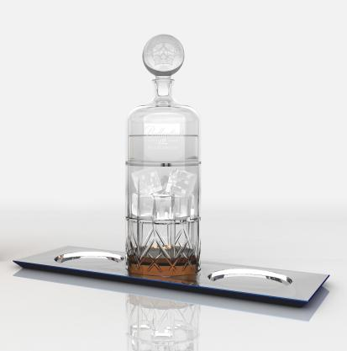
Critically acclaimed British interior and product designer, Lee Broom, and renowned international Scotch whisky, Ballantine’s 12 Year Old, have collaborated to launch a new limited edition serving ritual. ‘Ballantine’s 12 by Lee Broom’ will be launched at the Salone Del Mobile in Milan, the international design and furniture show, in April 2012.

The new ritual has been influenced by vintage crystal whisky decanters, with a contemporary twist, reflecting the cultural amalgam of old meets new predominant in Broom’s work. The designer has used his expertise in using cut crystal to create this new, luxurious serving ritual for Ballantine’s 12 Year OId.

The decanter breaks into three individual sections allowing the item to be used in a single or shared occasions:
- The base acts as the whisky glass, sealing the notes and aromas
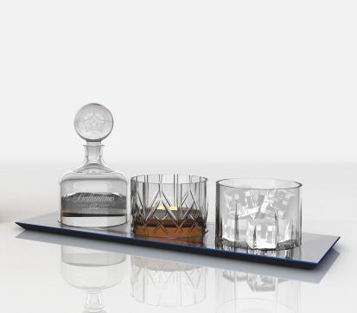
- The middle section is to contain ice cubes and can also be used as a secondary whisky glass
- The top section is to hold water or another mix that enhances the aromas of Ballantine’s 12 Year Old
- The decanter can also be used to prepare cocktails, replacing the ice and water with other ingredients

The serving ritual will complement its launch platform at Broom’s first, solo exhibition at the Salone del Mobile. Entitled Public House, the show is inspired by the age-old institution of the British pub, with a multi-dimensional, surreal twist, that will bring a truly British experience to the Ventura Lambrate design district.
The ritual will be released in a limited edition of 200 serving rituals to global markets including the UK, France, Mexico and Brazil.

Lee Broom said “I am delighted to be collaborating with Ballantine’s 12 Year Old. As a British designer who designs and manufactures all of my collections in the UK, it is a wonderful opportunity to collaborate with a heritage British label to reinterpret my design style into a new medium.”

Peter Moore, Ballantine’s Global Brand Director, said “We are delighted to be working with Lee Broom on Ballantine’s. Lee is an outstanding designer whose philosophy and values complement the brand perfectly. His work subtly mixes traditional and heritage cues with a modern and elegant twist very much like Ballantine’s 12 Year Old. A great match.”

This marks Lee’s second partnership with Ballantine’s 12 Year Old, after collaborating with five other critically acclaimed European artists to launch the concept bar ‘Art of BEYOND’ in 2011.
For more press information on Lee Broom, please contact Camron: Tel: +44 20 7420 1700
Charlie Bury: charlotte.bury@camronpr.com Roberta Snape: roberta.snape@camronpr.com Margaret Callanan: margaret.callanan@camronpr.com
WWW.LEEBROOM.COM | WWW.LEEBROOM.COM/BLOG | WWW.TWITTER.COM/LEEBROOM

