APRIL 2012

LAUNCH OF CRYSTAL BULB, LEE BROOM
SALONE DEL MOBILE 2012
17 – 22 APRIL 2012

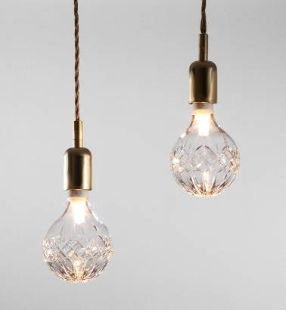
This April, critically acclaimed British product and interior designer, Lee Broom, will launch Crystal Bulb as part of his first, solo exhibition in Milan during the Salone Del Mobile – Lee Broom Public House.

Taking inspiration from the delicate craftsmanship of crystal cutting, and following Broom’s hugely successful Decanterlight, Crystal Bulb combines industrial influences with decorative qualities, transforming the everyday light bulb into an ornamental light fitting.

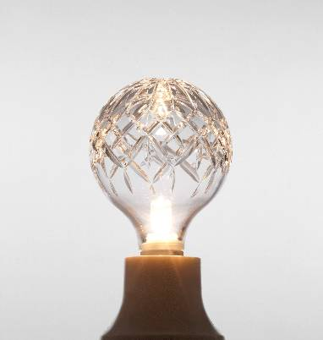
Individually hand blown, each Crystal Bulb is cut with the decanter pattern and etched with a Lee Broom logo. Broom has collaborated with experts at Cumbria Crystal in the UK, keeping true to his signature design ethos of working with British craftsmen.

Crystal Bulb casts beautiful shadows across a room. It is designed to fit any standard ceiling, wall or lamp fitting, and can be hung solo or in clusters, as well as used with a light shade to create enchanting light effects.

On designing the Crystal Bulb Lee Broom says “I wanted to create a light bulb as a more accessible design product and incorporating cut crystal seemed the most logical design as this has become a familiar style within my product ranges.”

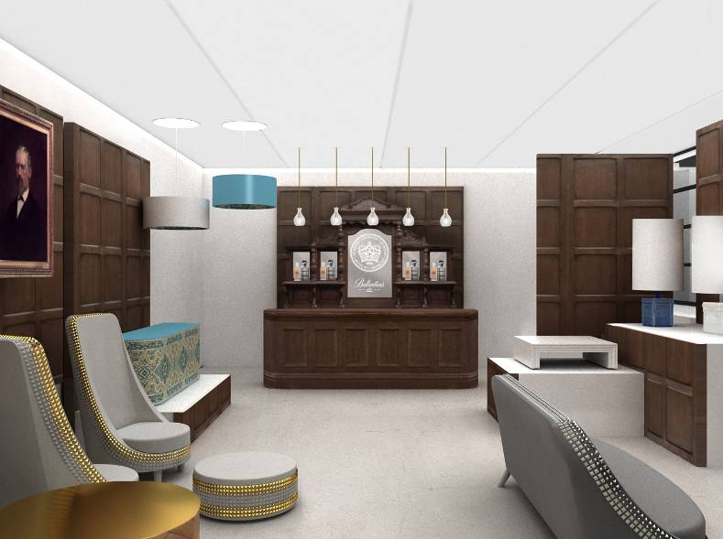
Crystal Bulb complements Broom’s Public House exhibition at the Salone Del Mobile. Inspired by the age-old institution of the British pub, with a multi-dimensional, surreal twist, Public House will bring a truly British experience to the Ventura Lambrate Design district. In collaboration with renowned international Scotch whisky, Ballantine’s 12 Year Old, Broom will also showcase an exclusive serving ritual, influenced by vintage crystal whisky decanters.

Crystal Bulb Key Facts
- The Crystal Bulb shell is detachable from its filament to allow replacement
- It uses an energy efficient, dimmable, halogen bulb with 2000 hour life-span

LEE BROOM, PUBLIC HOUSE, VIA VENTURA NR. 5, 20134, MILANO
- General Opening Hours: Tuesday 17 April 2012 – Sunday 22 April 2012, 10am – 8pm
- Press Conference (Invitation Only): Wednesday 18 April 2012, 9am – 11am
- Open Evening (Invitation Only): Wednesday 18 April 2012, 8pm – 10pm
- For more press information on Lee Broom, please contact Camron: Tel: +44 20 7420 1700

- Charlie Bury: charlotte.bury@camronpr.com
- Roberta Snape: roberta.snape@camronpr.com
- Margaret Callanan: margaret.callanan@camronpr.com

WWW.LEEBROOM.COM | WWW.LEEBROOM.COM/BLOG | WWW.TWITTER.COM/LEEBROOM

